NeuroFleetX – AI Powered Urban Fleet & Traffic Intelligence

INFOSYS SPRINGBOARD VIRTUAL INTERNSHIP 6.0
JAVA BATCH 7 – TEAM B

-Ganesh S
- Role: Admin Module, Authentication, Driver Module

Agenda
- Introduction
- Problem Statement
- Objectives of the Project
- Scope of the Project
- Deliverables
- User Roles and Responsibilities
- Functional Modules
- Technology Stack Used
- Milestones and Project Progress
  - Milestone 1
  - Milestone 2
  - Milestone 3
- Results and Outputs
- Conclusion

1. Introduction
NeuroFleetX is a smart fleet and traffic management system that uses modern web technologies and AI-assisted logic to manage vehicles, traffic conditions, and user roles efficiently. My contribution mainly focused on building secure access to the system, managing core admin functionalities, and implementing AI-related backend features that support route suggestions and traffic analysis.

2. Problem Statement
As cities grow, traffic management becomes more complex. Existing systems do not provide secure role-based access, intelligent route guidance, or real-time traffic insights. Manual handling of users, drivers, and traffic data leads to inefficiency and delays. This project addresses these issues by introducing a centralized, secure, and intelligent fleet management system.

3. Objectives of the Project
The key objectives of this project are:
- To provide secure login and registration for all users
- To manage drivers and users efficiently
- To analyze traffic conditions using AI-assisted logic
- To support route suggestions for better navigation
- To provide drivers with traffic and vehicle status insights

4. Scope of the Project
The scope of my contribution includes:
- Secure authentication for all roles
- Admin-level management of users and drivers
- Backend implementation of AI analytics and AI tools
- Driver-side traffic analysis and alerts
The project focuses on combining backend intelligence with frontend visualization to improve traffic decision-making.

5. Deliverables
The following deliverables were achieved through my work:
- Secure login and registration pages
- Role-based access control using JWT
- Admin features for managing drivers and users
- AI tools for route suggestion
- Backend APIs for AI analytics
- Driver module features for traffic and vehicle status

6. User Roles and Responsibilities
- Admin: Manages users, drivers, analytics, and AI tools
- Manager: Monitors traffic data and risk zones
- Driver: Views traffic status, vehicle condition, routes, and alerts

7. Functional Modules

7.1 Authentication Module (Login & Registration)
Purpose:
This module provides secure access to the system for all users.
Description:
The login and registration functionality allows Admin, Manager, and Driver to access the system based on their roles. JWT authentication is used to secure APIs and protect pages from unauthorized access. After login, users are redirected to their respective dashboards.
Key Features:
- Login page for Admin, Manager, and Driver
- Registration page for creating new users
- JWT-based authentication and authorization
- Role-based access control

7.2 Create User (User Management – Admin)
Purpose:
To manage system users and control access.
Description:
The Create User module allows the Admin to add new users such as Managers and other Admins. Each user is assigned a role, which decides their access level in the system. This helps in maintaining proper control and security.
Key Features:
- Create Admin and Manager accounts
- Assign roles during user creation
- View and manage existing users
- Control system access through roles

7.3 Manage Driver (Admin Module)
Purpose:
To handle all driver-related information in the system.
Description:
This module allows the Admin to add, update, and manage driver details. Driver information such as license number, contact details, and experience is stored and maintained. This ensures proper driver assignment and tracking.
Key Features:
- Add new drivers
- Update driver details
- View driver information
- Manage driver records efficiently

7.4 AI Analytics (Backend – Admin Module)
Purpose:
To analyze traffic data and identify risk zones.
Description:
The AI Analytics backend processes traffic data and categorizes locations based on congestion levels. It provides structured data to the frontend for visual representation using charts and indicators. This helps admins and managers understand traffic risk patterns.
Key Features:
- Traffic congestion analysis
- Risk zone identification
- Risk level classification (Low, Medium, High, Critical)
- Backend APIs for analytics data

7.5 AI Tools – Route Suggestion
Purpose:
To support intelligent route guidance.
Description:
This module implements backend logic to suggest efficient routes based on traffic conditions. Basic AI/ML-supported logic is used to choose better routes. The design allows easy integration of advanced ML models in the future.
Key Features:
- Route suggestion logic
- Traffic-aware route selection
- ML-ready architecture for future enhancement

7.6 Driver Module – Traffic Analysis
Purpose:
To help drivers understand traffic conditions.
Description:
The traffic analysis feature displays traffic information to drivers in a simple and understandable format. It helps drivers choose safer and faster routes during trips.
Key Features:
- Traffic condition display
- Route comparison support
- Improved driving decisions

7.7 Driver Module – Vehicle Status
Purpose:
To monitor vehicle health and status.
Description:
This module shows vehicle-related information such as current status and health details. Drivers can easily check whether the vehicle is in good condition before or during a trip.
Key Features:
- Vehicle status display
- Health-related information
- Supports safe driving

7.8 Alerts Module (Driver View)
Purpose:
To notify drivers about important issues.
Description:
The Alerts module displays traffic and safety alerts to drivers. Alerts are categorized by severity, helping drivers quickly understand the urgency and take necessary action.
Key Features:
- Traffic alerts
- Safety alerts
- Severity-based alert display
8. Technology Stack Used
- Frontend: React
- Backend: Spring Boot
- Database: MySQL
- Security: JWT Authentication
- AI & Maps: AI-assisted logic, OpenStreetMap

9. Milestones and Project Progress
Milestone 1
- Requirement analysis
- Project planning
- Role allocation
- Technology selection
Milestone 2
- Login and Registration pages
- JWT-based authentication
- Admin module:
  - Manage Drivers
  - Create and Manage Users
Milestone 3
- AI Analytics (Backend implementation)
- AI Tools for route suggestion
- Driver module enhancements:
  - Traffic analysis
  - Vehicle status
  - Alerts handling

10. Results and Outputs
- Secure authentication system for all roles
- Functional admin controls for users and drivers
- AI-based backend support for traffic analytics
- Route suggestion feature working with map integration
- Driver dashboard showing traffic, vehicle status, and alerts
- 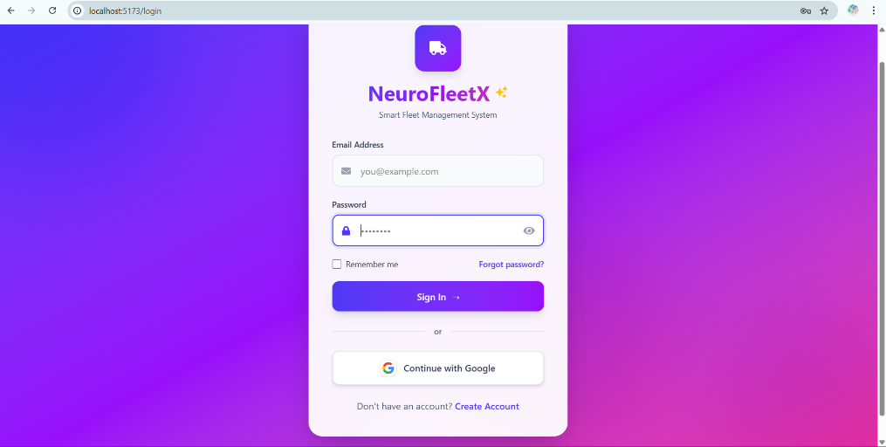

- 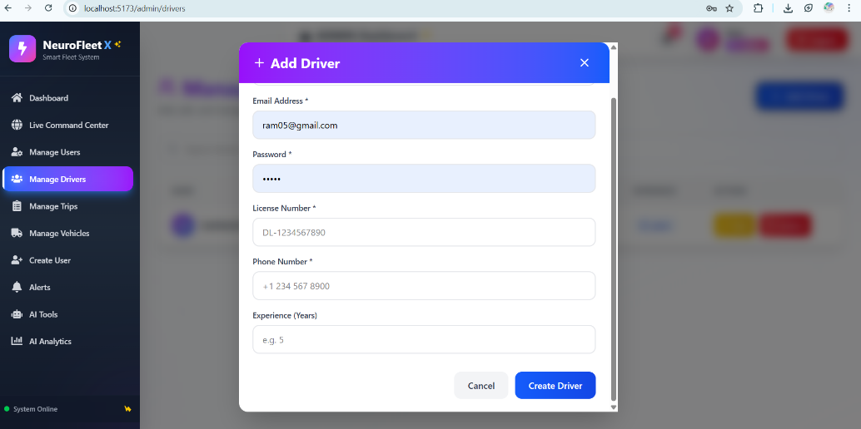

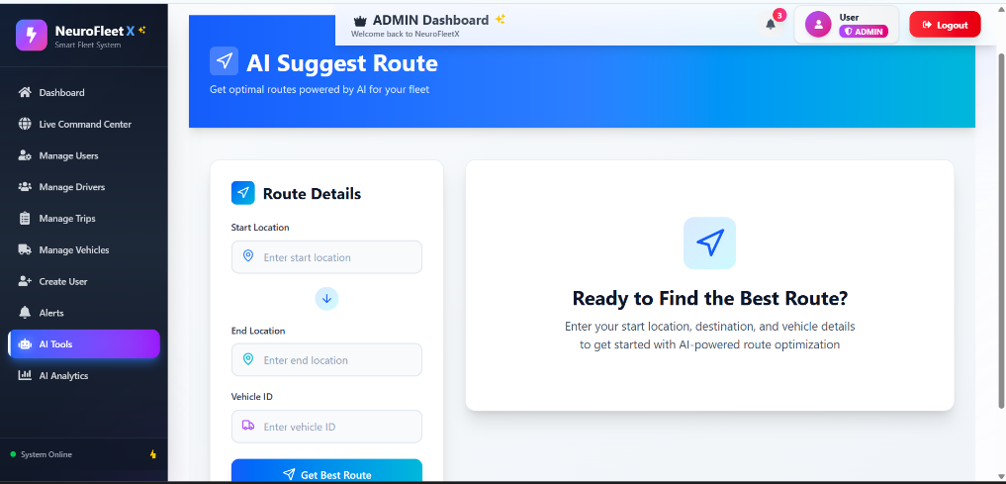

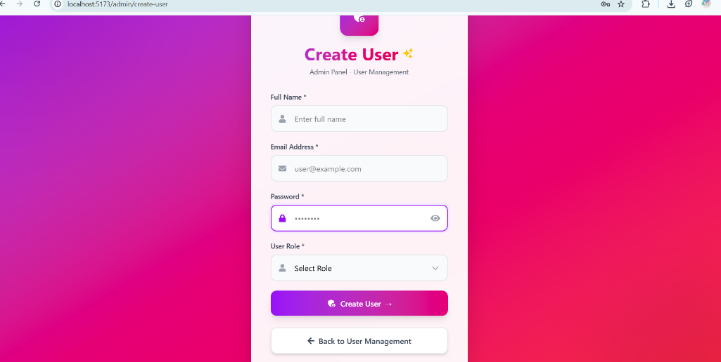

- 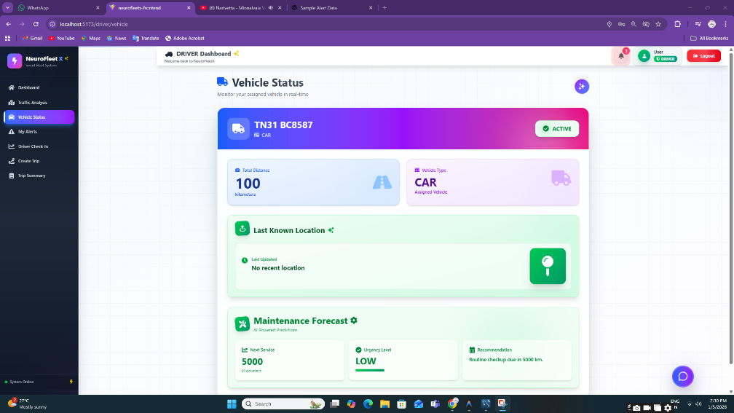

- 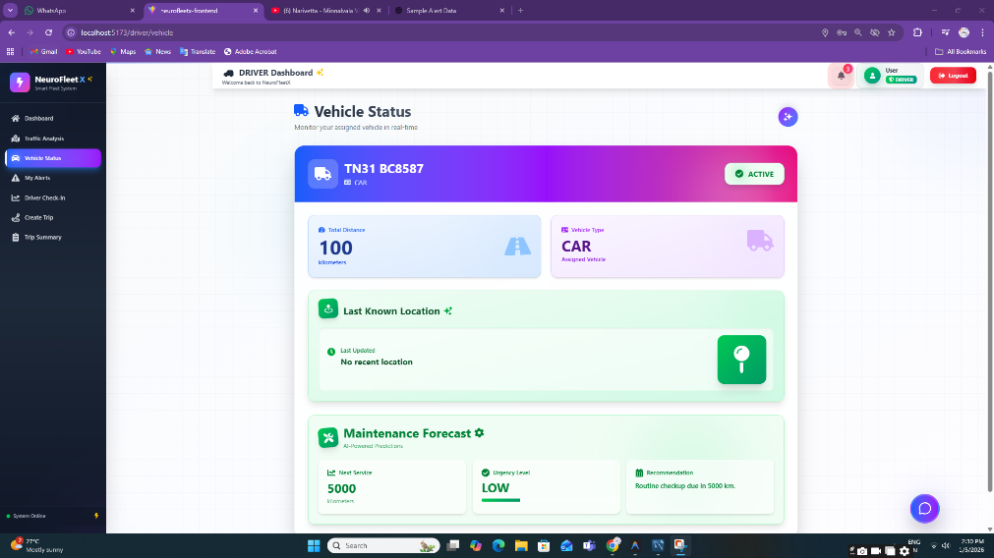

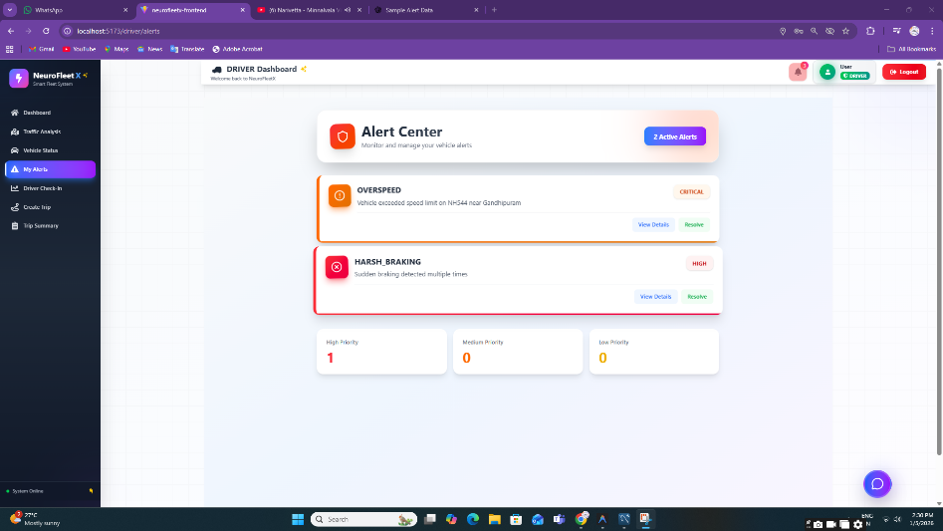

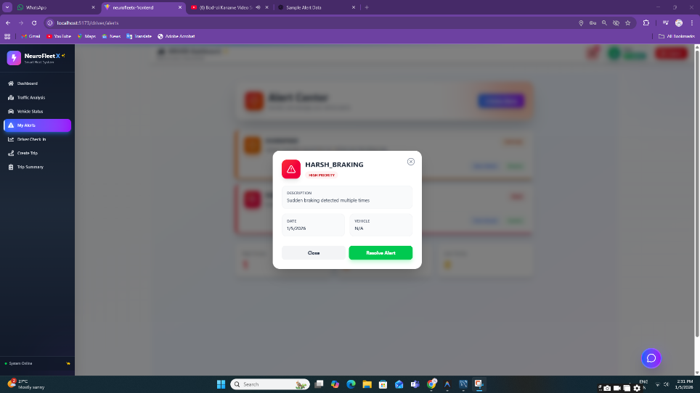

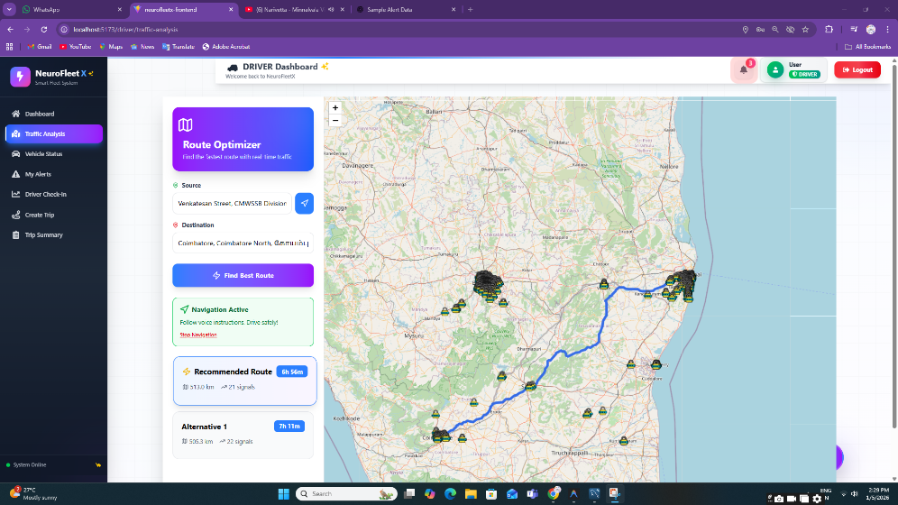

11. Conclusion
In conclusion, my contribution to NeuroFleetX focused on building secure access, core admin functionalities, AI backend logic, and driver-related features. This work helped me gain hands-on experience in authentication, backend API development, AI-assisted logic, and role-based system design. The project can be further enhanced by adding advanced machine learning models and real-time data integration.

